SEO Metadata
- Focus Keyword: best web development company in Bangalore
- Meta Title: Best Web Development Company in Bangalore (2026 Guide) | Brewing Ideaz
- Meta Description: Looking for the best web development company in Bangalore? Learn what to evaluate — tech stack, process, scalability, pricing & red flags — before you hire.
- URL Slug: /best-web-development-company-in-bangalore

Secondary Keywords
- web development company in Bangalore
- website development company in Bangalore
- custom web development services in Bangalore
- web application development Bangalore
- ecommerce website development Bangalore
- full stack development company Bangalore
- software development company Bangalore
- CMS website development Bangalore
- responsive website development Bangalore
- Brewing Ideaz Bangalore

Internal Linking Suggestions
- /services/ or /web-development/
- /contact-us/
- /portfolio/ or /case-studies/

Best Web Development Company in Bangalore: A Practical Guide to Choosing the Right Partner
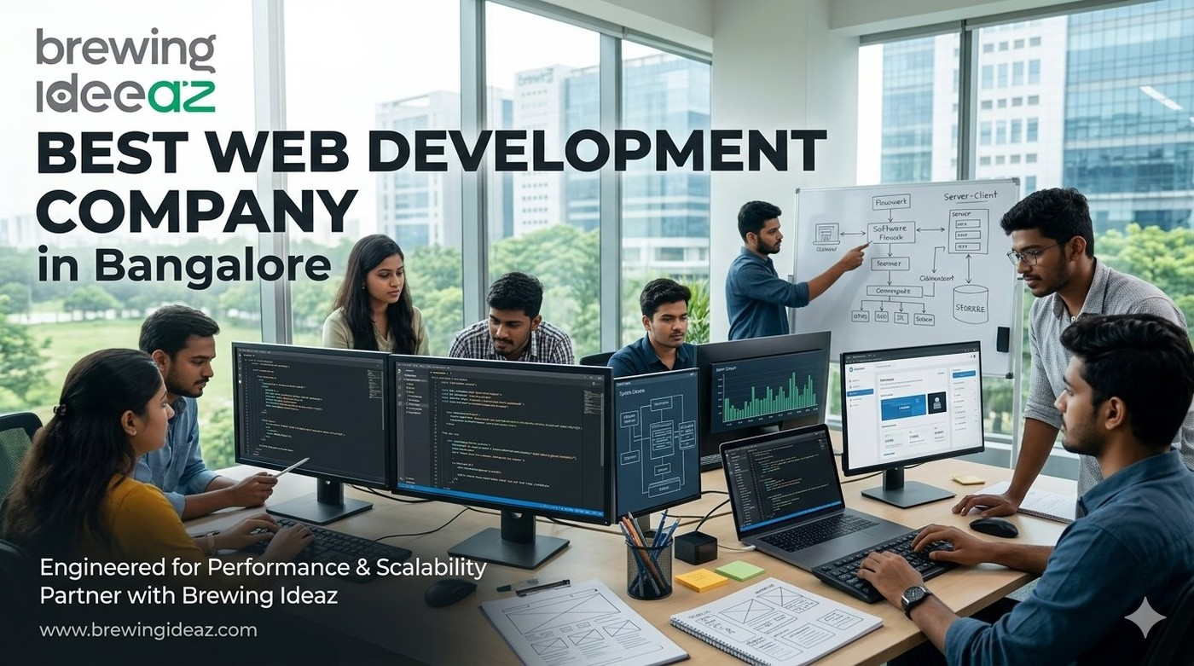
Bangalore is one of India’s strongest technology hubs, which means the market for web development services is crowded. Many companies claim to be the “best web development company in Bangalore.” The difference between a reliable engineering partner and a risky one often shows up months later in performance, maintainability and cost of change. This guide helps you evaluate development partners systematically.

What “Best” Means in Web Development
A strong web development company delivers clean, scalable, secure and maintainable code that supports your business goals. Beyond writing features, the best partners think about architecture, performance, testing, documentation and long-term ownership.
Fit is essential. A team experienced in marketing websites may not be ideal for a complex SaaS product or high-traffic platform, and vice versa.

Key Factors to Evaluate Before Hiring

Technical depth and relevant experience
Review past projects similar in complexity and tech stack to yours.

Engineering process
Ask about architecture decisions, code reviews, testing practices, CI/CD and documentation.

Scalability and performance awareness
Confirm they consider load, caching, database design and future growth.

Team composition and seniority
Understand who will architect, develop and review the work.

Communication and project management
Clear updates, realistic estimates and transparent handling of scope changes matter.

Post-launch support and ownership
Clarify warranty period, knowledge transfer, source-code ownership and ongoing maintenance options.

Why Bangalore-Based Web Development Companies Often Stand Out
The city has a deep talent pool and many teams experienced in building products for startups and enterprises alike.

Questions to Ask Before You Hire
- Can you walk me through a recent project of similar complexity and the technical decisions you made?
- What is your typical process from discovery to deployment?
- How do you handle code quality, testing and documentation?
- Who will be the core engineering team on my project?
- What does post-launch support and knowledge transfer look like?

Red Flags to Watch For
Be cautious of companies that cannot discuss architecture or testing, quote extremely low prices without clear scope, refuse to share code samples or references, or push proprietary platforms that lock you in.

Final Thoughts
The best web development company in Bangalore for your project is the one that understands your technical and business requirements, follows solid engineering practices, and leaves you with clean, ownable code.

Ready to Discuss Your Development Project?
Brewing Ideaz is based in Bengaluru (Sarjapur – Marathahalli Road) with a branch office in Kolkata.
Call or WhatsApp: (+91) 62915 47048 Email: info@brewingideaz.com

30 Frequently Asked Questions About Web Development Company in Bangalore
- What is a web development company? A web development company designs, builds, tests and maintains websites and web applications according to a business’s requirements.
- How do I choose the best web development company in Bangalore? Evaluate technical depth, relevant projects, engineering process, team seniority, communication, pricing, and post-launch support.
- What services does a web development company provide? Services typically include custom website development, web applications, e-commerce development, CMS implementation, API integrations, and maintenance.
- How much does web development cost in Bangalore? Cost depends on scope, features, integrations, technology, and timeline. Request a detailed proposal with deliverables and assumptions.
- How long does it take to develop a website? Timelines vary from a few weeks for a marketing site to several months for complex web applications, depending on scope and feedback cycles.
- What is the difference between front-end and back-end development? Front-end development builds what users see and interact with in the browser. Back-end development handles servers, databases, and business logic.
- What is full-stack development? Full-stack development covers both front-end and back-end work, from user interface to server logic and databases.
- What is a CMS and do I need one? A content management system lets non-technical users update website content. It is useful if you plan to publish or edit content regularly.
- Should I choose a custom website or a template-based one? Custom builds offer flexibility and scalability; templates can be faster and cheaper for simple needs. The right choice depends on your goals and budget.
- What technologies do web development companies use? Common choices include HTML, CSS, JavaScript frameworks, Node.js, Python, PHP, and various databases. The stack should fit your requirements.
- What is responsive web development? It ensures a website adapts to different screen sizes and devices so users get a usable experience on mobile, tablet, and desktop.
- Why is website performance important? Faster websites provide a better user experience and can support engagement and conversions.
- What is website security and how is it handled? Security includes secure coding practices, HTTPS, updates, access control, and backups to reduce common risks.
- What is an API integration? An API integration connects your website with other systems such as payment gateways, CRMs, or analytics tools.
- Can a web development company build an e-commerce website? Yes. Many companies build online stores including product catalogues, carts, payments, and order management.
- What is a web application? A web application is interactive software that runs in a browser, such as a dashboard, portal, or booking platform.
- What does a typical web development process look like? Discovery, planning, design, development, testing, deployment, and post-launch support.
- Who owns the source code after the project? Ownership depends on the contract. Confirm source-code ownership, licences, and third-party dependencies in writing.
- What is post-launch support in web development? Support may include bug fixes, updates, monitoring, training, and maintenance under a defined agreement.
- What should I prepare before contacting a web development company? Your goals, target users, required features, reference sites, budget range, and timeline.
- How do I evaluate a web development company’s portfolio? Review live projects for similar complexity, performance, usability, and ask about the technical decisions behind them.
- What are red flags when hiring a web development company? Vague scope, unrealistic timelines, unwillingness to share references, poor communication, and unclear ownership terms.
- What is the difference between web design and web development? Web design focuses on look, layout, and user experience; web development turns designs into a working website or application.
- Can a web development company help with SEO? They can implement technical SEO foundations such as clean structure, speed, and mobile-friendliness. Ongoing SEO may need separate services.
- What is website maintenance? Regular updates, backups, security checks, bug fixes, and content changes to keep a site running well.
- How important is testing in web development? Testing helps identify bugs and usability or performance issues before launch and after changes.
- What is agile development? An iterative approach where work is delivered in short cycles with regular feedback, useful when requirements evolve.
- Why choose a Bangalore-based web development company? A local team may offer convenient communication, overlapping working hours, and familiarity with the regional market.
- Does a web development company guarantee results? No company can reliably guarantee business outcomes; results depend on strategy, market, content, and ongoing effort.
- How can I contact Brewing Ideaz for web development services in Bangalore? Call or WhatsApp +91 62915 47048 or email info@brewingideaz.com to discuss your project.

